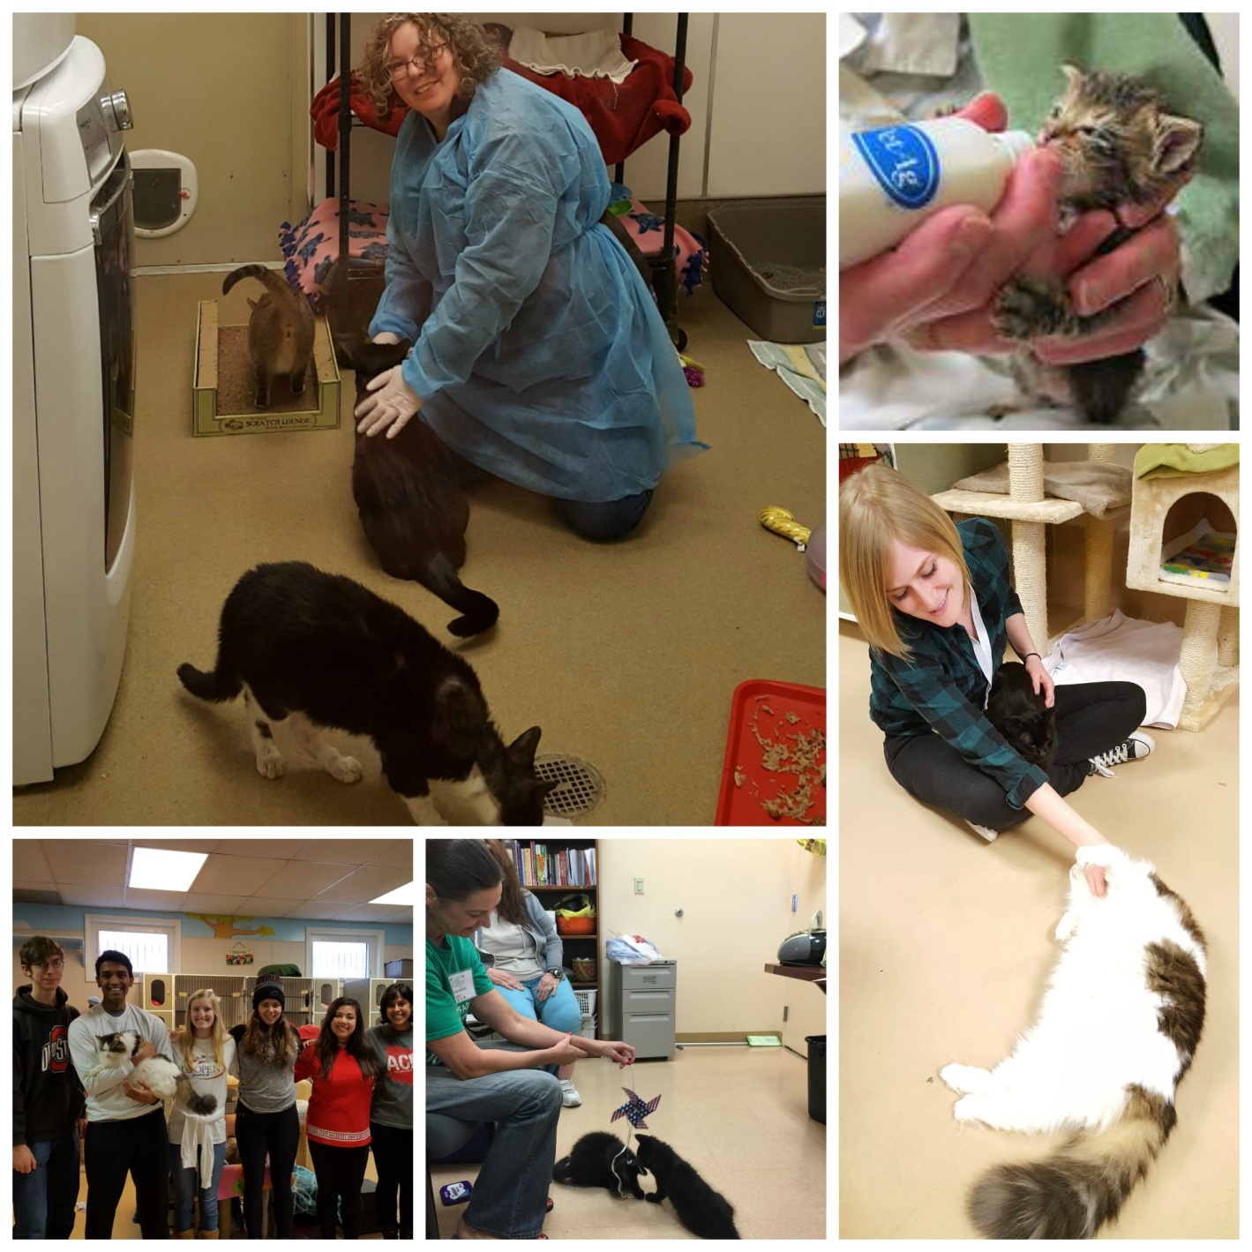

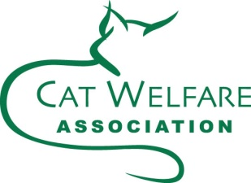**Volunteer Handbook**

Version 9I 2021

Cat Welfare

741 Wetmore Road

Columbus, Ohio 43214

614.268.6096

**Table of Contents**

Welcome! 3

VOLUNTEER OPPORTUNITIES 4

ABOUT CAT WELFARE 7

ADMISSIONS, ADOPTIONS AND FOSTER CARE 11

REVELANT POLICIES AND PROTOCOLS 13

VOLUNTEER WAIVER AND AGREEMENT 16

#### Welcome!

Thank you for your willingness to donate your time and energy to The Cat Welfare Association (CWA).

Our volunteers are instrumental to the success of our cats and the entire organization. My goal is to develop a volunteer team that is positive, dedicated and educated. We all love our cats and work hard to make them happy during their time at the shelter.

Away from the shelter, we strive to educate the community about CWA, our cats, and donation opportunities. As a volunteer you will have fun, make friends, and have the rewarding feeling of knowing that you are helping cats who need you!

Please carefully read this handbook to become familiar with The Cat Welfare Association. Contact me with any questions you may have about Cat Welfare.

I am happy to have you join our dedicated team of volunteers. I look forward to working with you and hope you find your volunteer activities and responsibilities rewarding.

Thank you!

Jennifer Howell

Volunteer Coordinator 614.268.6096

[volunteers@catwelfareassoc.org](mailto:volunteers@catwelfareassoc.org)

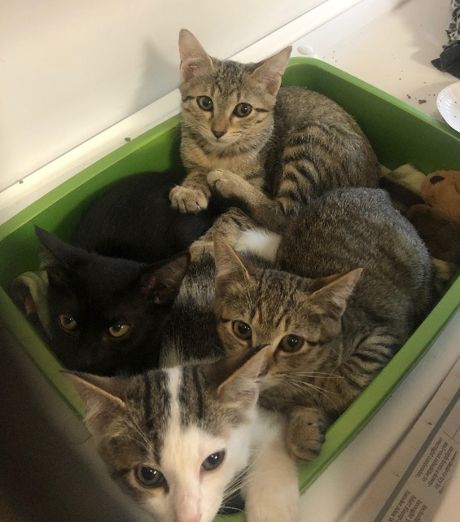 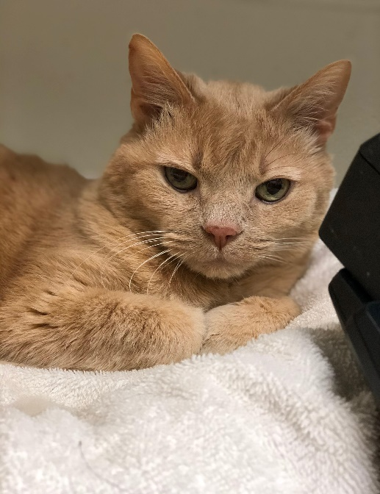

#### VOLUNTEER OPPORTUNITIES

### SOCIALIZATION

Socialization is a very important volunteer activity at CWA. Since all of our cats are strays, many have had very little positive human interaction. With a short term goal for each shelter cat to have one-on-one human time at least once each day, our volunteers are vital! What’s the long term goal? Adoption, of course! And the more comfortable the cats are with people, the faster they are adopted! Socialization involves petting, grooming, playing, chatting, and generally loving on the shelter cats.

### C:\Users\user\Pictures\Cat Caper Facebook\woman with cat.jpg C:\Users\user\Pictures\Catique\cat brushy.jpg

### THE CATIQUE

The Catique is CWA’s upscale resale shop. Proceeds from the sales at this shop directly fund shelter operations. We need volunteers to help sort and price donations, create displays, stock newly donated items, etc. While this role has no direct contact with cats, please know that the shelter relies on these funds to care for our cats. This is a very important way you can help.

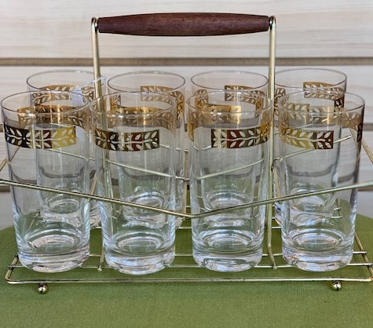 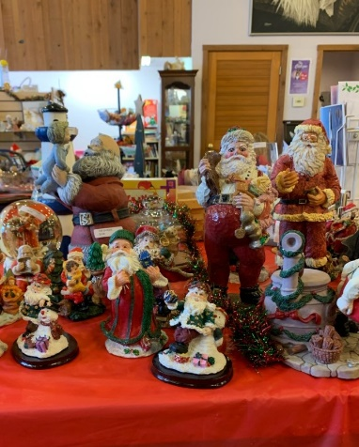

### FOSTER CARE

Fostering is the perfect opportunity for volunteers who love cats, but cannot commit to owning one right now. Or you may have cats already, but have extra space in your home to temporarily have cats or kittens live with you. Cats need a foster home for many reasons ranging from illness or being a small kitten in need of bottle feeding to needing a quiet place to recover from surgery or illness. Training and all supplies are provided to volunteers who can meet our foster requirements. Letting go is often the hardest part!

### simon C:\Users\user\Pictures\bottle baby.jpg

### OFF-SITE OPPORTUNITIES

Many opportunities are available for Cat Welfare to reach out to the public such as adoption events of various types. Off-site opportunities vary throughout the year. If you enjoy attending social events and meeting a variety of new people, please consider becoming a CWA off-site ambassador. This can include dressing as our mascot Lucky, or staffing a table at a festival or business. All new representatives are trained and paired with a seasoned volunteer or staff member for their first event.

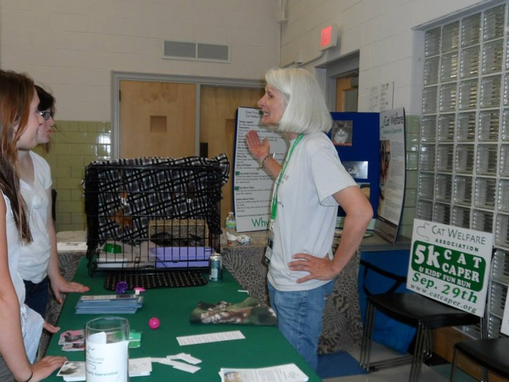 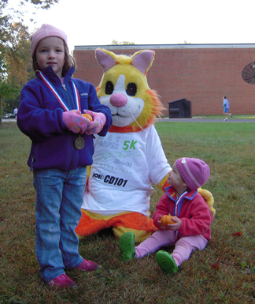

### ASSISTED LIVING VISITS

Rehab centers/assisted living center visits are quite popular. We often have activity directors contact us asking if we will bring cats to their facility to spend time with the residents. Typically this involves picking up one or two cats from the shelter, driving to the facility, and spending about an hour visiting before returning the cats to the shelter. Training and guidance are provided. Cats get pets and the people get purrs. Everybody wins!

### GREETERS

Greeters are a very important supplement to our staff. During our busiest days and times on weekends and evenings, a select group of specially trained volunteers greets each customer as they enter the shelter. They ask if this is their first CWA visit and acquaint them with ways to make their shelter visit a success. Our greeters’ extra help during busy times allows the staff to focus on the adoption process and ongoing cat care. We ask that our greeters commit to one shift per month, be outgoing, and represent CWA in a positive, professional manner.

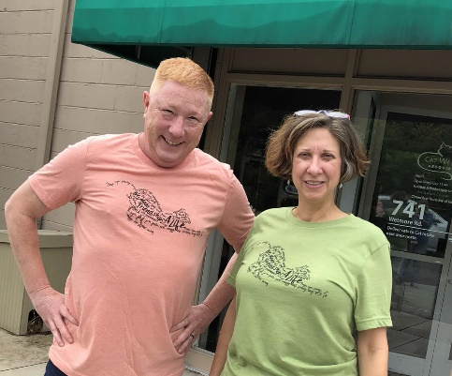

### ADMINISTRATIVE HELP

Administrative help is sometimes requested by our office support staff. This type of work is usually done at the shelter, but can sometimes be completed at home depending on the task. Our administrative help requests range from data entry to stuffing envelopes.

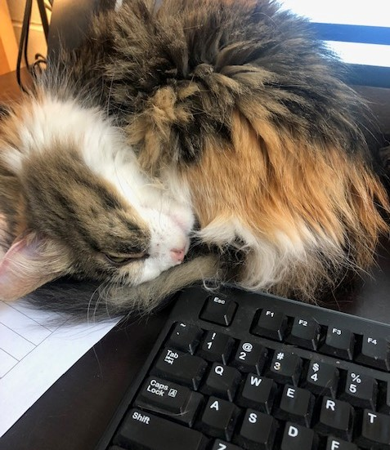 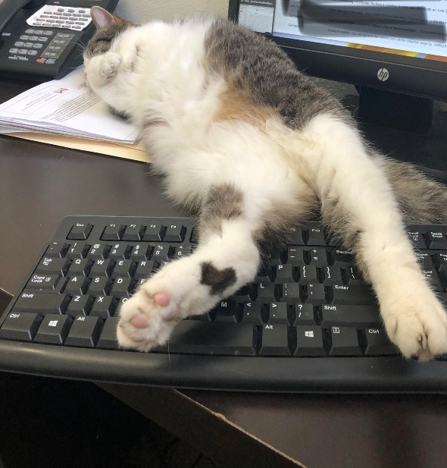

#### ABOUT CAT WELFARE

### LOCATION AND CONTACT INFORMATION

Cat Welfare is located at 741 Wetmore Rd., Columbus, Ohio 43214. The organization’s official name is The Cat Welfare Association, Inc., although it is often referred to as “Cat Welfare” or “CWA.” The office telephone number is 614-268-6096. The official website is [www.catwelfareassoc.org](http://www.catwelfareassoc.org) and you can find us on [www.facebook.com/catwelfareassoc](http://www.facebook.com/catwelfareassoc) and  [www.instagram.com/catwelfareassoc](http://www.instagram.com/catwelfareassoc).

 

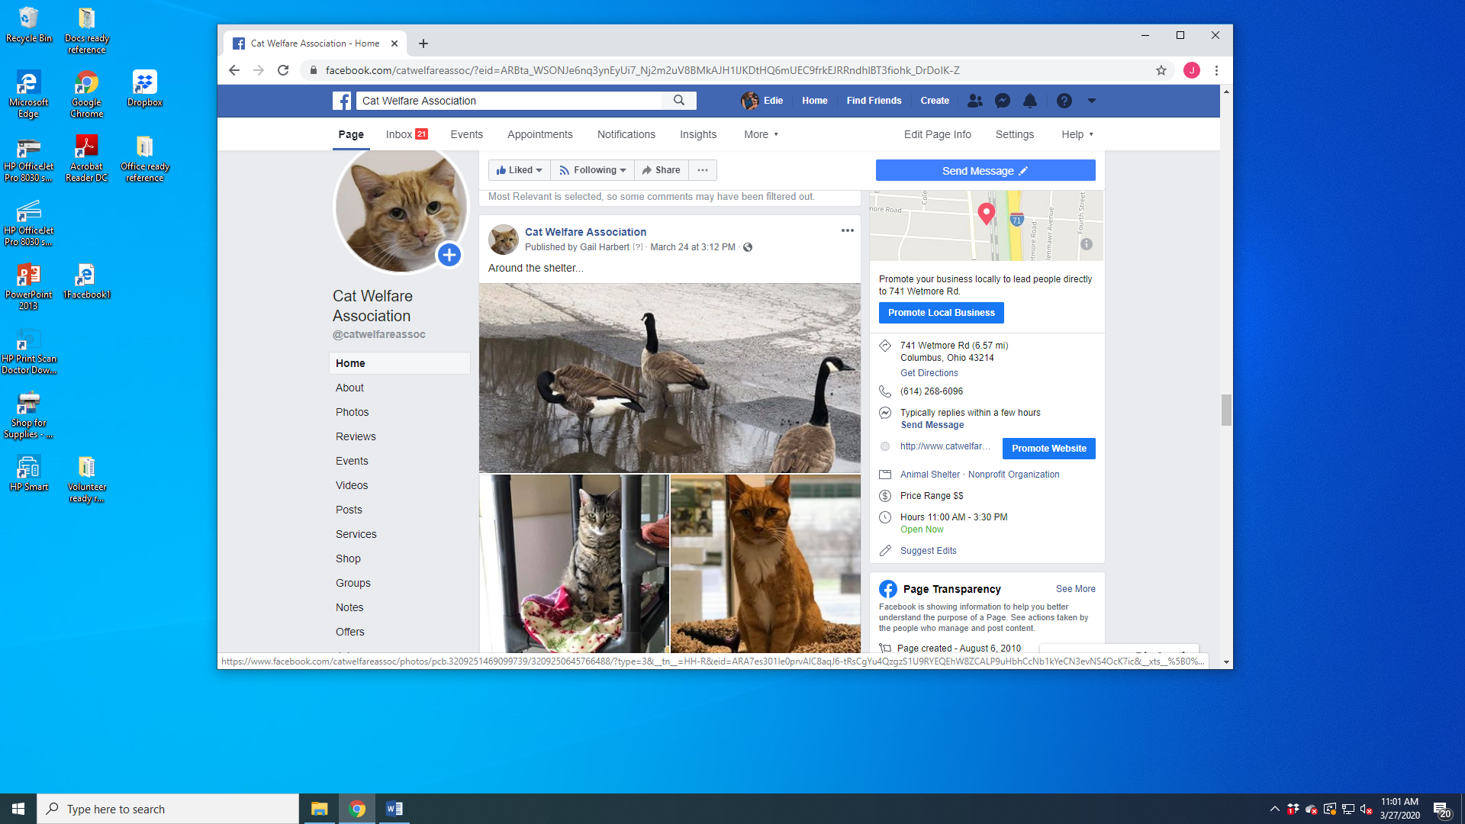

### MISSION

The Cat Welfare Association is a non-profit organization dedicated to the care of and education about cats and kittens. Our pledge is to cherish, nurture and provide veterinary care for homeless, abused, injured and abandoned cats. We strive to find each cat an appropriate, safe and loving home, allowing those not placed to live their lives in the care and comfort of our shelter.

Cat Welfare is a limited intake facility. This means that cats are admitted into the shelter only when space is available. However, pregnant or injured cats, as well as cats adopted from Cat Welfare are always accepted.

### VISION

The Cat Welfare Association envisions a community, and a world, in which cats are valued members of our animal population and are cared for, protected and cherished for their

companionship, unique personalities and place in world history.

### GOALS

* + To increase public awareness of the value of cats as unique members of our animal community and of the community-at-large
  + To offer shelter to homeless cats where they can feel safe, be well cared for, and receive necessary medical treatment
  + To encourage adoptions by providing a welcoming place where potential cat adopters and cats needing homes can become acquainted
  + In order to minimize and, hopefully, eliminate the population of unwanted, uncared for cats, to increase public awareness of the importance of spaying/neutering, and to provide financial assistance to low-income households and those caring for feral cats to cover the cost of the surgeries
  + To support cat owners by providing information and guidance to help them become responsible and loving owners

### FINANCIAL SUPPORT

The Cat Welfare Association, Inc. is supported by membership and adoption fees, donations, bequests, grants, fundraisers and special events. No government funding is received.

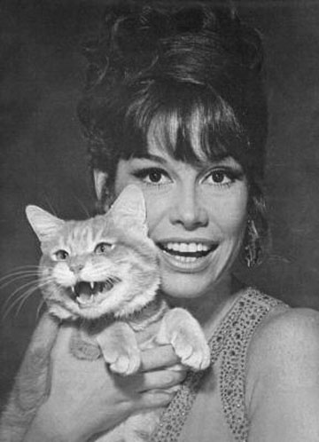

### HISTORY

In 1945, seven concerned people met in the home of Mrs. Virginia Kunkler to form an organization to promote better care and understanding of cats and to provide for the physical welfare of homeless cats and kittens. A constitution was adopted and Cat Welfare was born!

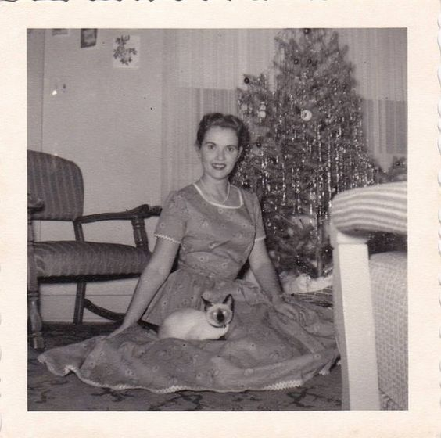 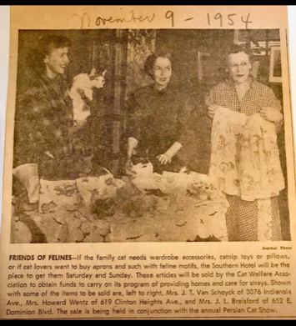

In 1952, Cat Welfare was incorporated as a tax-exempt nonprofit organization and became The Cat Welfare Association, Inc. Since there was no shelter building at the time, members housed cats in, and placed cats from, their homes. The decision also was made to spay/neuter all adult cats before placement in an effort to reduce pet overpopulation.

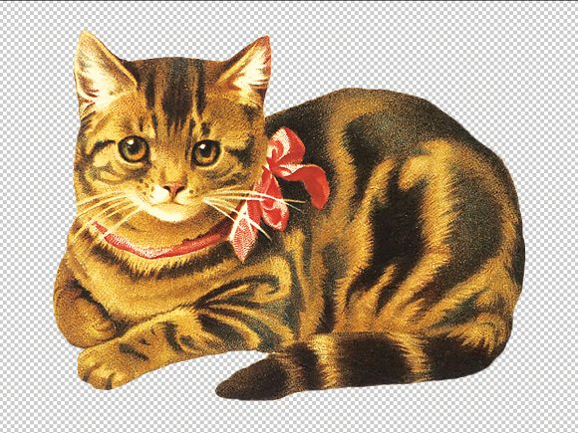 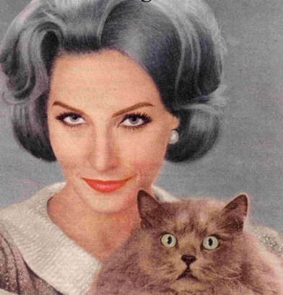

The following year (1953),Cat Welfare purchased the land and small building directly in back of the current Beechwold Veterinary Hospital. While foster homes were still heavily utilized, this small building became the first official location for the shelter. A decade later, the building was torn down and replaced with a larger facility which included space for our “garage sale.” This sale evolved into The Catique, our off-site resale shop.

During the 1970's, Cat Welfare established an Altering Fund to provide financial assistance to those who cannot afford the cost of neutering their pets. In addition, the decision was made to include spaying/neutering as part of the adoption fee charged for kittens. In 2008 it was decided that all kittens would be spayed or neutered before adoption.

Cat Welfare continued to grow during the 1980's and 1990's, making it necessary to again look to expansion. In May 1999, CWA moved into the larger and newly remodeled facility at our present location, 741 Wetmore Road.

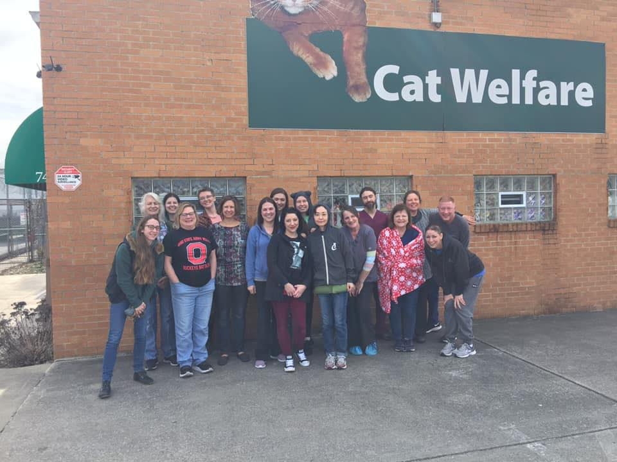 

The current facility has ~5,600 square feet with space dedicated specifically to admissions, medical examination and treatment, and isolation of ill cats and those recovering from injury or surgery. In 2001, a large all-season sunroom was added to our building to provide fresh air and sunlight for our permanent feline residents. The sunroom was built through a generous donation from Lillian Fobes, in memory of her husband Alfred and his cat, Gaylord.

Renovations continued as funds became available. In 2011 tile floors were replaced with epoxy flooring. The following year (2012) solid surface sinks were installed and the signage in and around the shelter was completely revamped. In 2014 a significant grant from The Joanie Bernard Foundation and monies from the estate of Marjorie Baker allowed Cat Welfare to renovate the space previously used by The Catique. This area is now dedicated to serving our resident felines and houses support operations. The Catique moved off-site and was transformed from a garage sale setting to a resale shop.

Cat Welfare has had an amazing past for over 75 years and with the continued support of our members and friends, a bright future lies ahead.

. 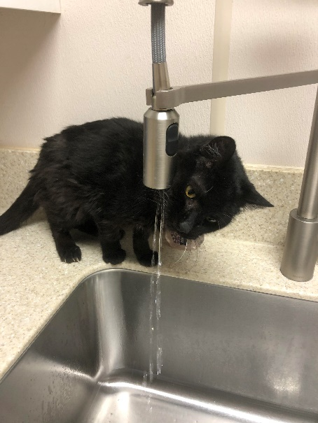 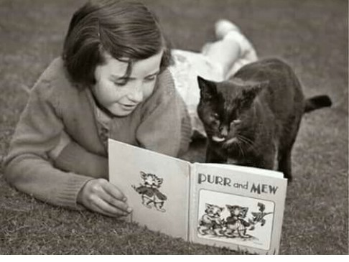

#### ADMISSIONS, ADOPTIONS AND FOSTER CARE

### ADMISSIONS

As mentioned earlier, Cat Welfare is a limited intake facility. This means that homeless cats and kittens are admitted into the shelter by appointment only when space is available.

However, pregnant or injured cats or those adopted from Cat Welfare are always welcome.

When a cat is admitted to the shelter, the person with the cat is asked to sign a release form, and is encouraged to make a surrender donation. Newly admitted cats are kept in isolation for a minimum of 48 hours (if possible). Kittens are held in isolation for as long as possible. Cat Welfare does not accept feral cats. (Feral cats are wild, unsocialized cats.)

### ADOPTIONS

Our cats are available for adoption by a loving and appropriate individual or family. Permanent adoption fees for cats and kittens are set by the Board of Directors; temporary special adoption fees may be established by shelter management with notification to the Board.

### Vaccinations

Each adult cat eligible for adoption has been tested for feline leukemia and FIV, and has received FVRCP-C, Bordetella vaccine, rabies and feline leukemia vaccinations. Kittens are tested for feline leukemia and FIV, and are given their first vaccinations.

### Spaying and Neutering

All adult cats and kittens are spayed or neutered before adoption.

### Health Guarantee

Each adopted cat has a 30-day health guarantee. If the cat becomes ill during this period, the new owner may contact Cat Welfare to make arrangements for medical treatment. Cat Welfare is not responsible for the cost of veterinary services that have not been pre-authorized.

### Returns

A 30 day return guarantee allows for the return of a cat **with a refund of the adoption fee or an exchange for another cat.** A cat adopted from Cat Welfare may be returned after any length of time (without refund), regardless of circumstances. In short, cats adopted from Cat Welfare are unconditionally accepted back into the shelter.

### Holds on Specific Cats

Cat Welfare does not offer a broad-based procedure to "hold" specific cats for interested adopters. An employee, at his/her discretion, may take the interested individual’s name and phone number and offer a courtesy call when the cat is ready to be adopted. CWA cannot guarantee that the cat will not be adopted by someone else in the meantime.

However, placing a courtesy call to the individual allows for good customer relations and, hopefully, the adoption of a cat by a person who will provide a permanent loving home.

### FOSTER CARE PROGRAM

Cat Welfare maintains a Foster Care Program administered by Cat Welfare’s program manager. Volunteers provide foster care, in their homes, for stray kittens (with or without the mom).

Kittens are kept in foster homes until they weigh at least 2.5 pounds (typically ~9 weeks old). Kittens and their moms are spayed or neutered and placed in the shelter for adoption as soon as possible. Foster care is also provided to cats with special needs until adoption is feasible.

Volunteers who provide foster care must be able to accept the risks associated with caring for young felines. An application process explains the commitment and responsibilities connected with this meaningful volunteer opportunity. If a foster cat or kitten requires medical care, the volunteer must first contact CWA’s program manager. Cat Welfare maintains ownership of the cats and kittens in this program and retains records of all medical care needed by, and provided to, fostered felines.

Our application to foster: <http://www.catwelfareassoc.org/assets/documents/application-to-foster-2014.pdf>

Our foster care agreement:

<http://www.catwelfareassoc.org/assets/documents/foster-agreement-2014-for-web.pdf>

Questions regarding our foster care program can be directed to Shelter Manager, Gail Harbert, 614.268.6096.

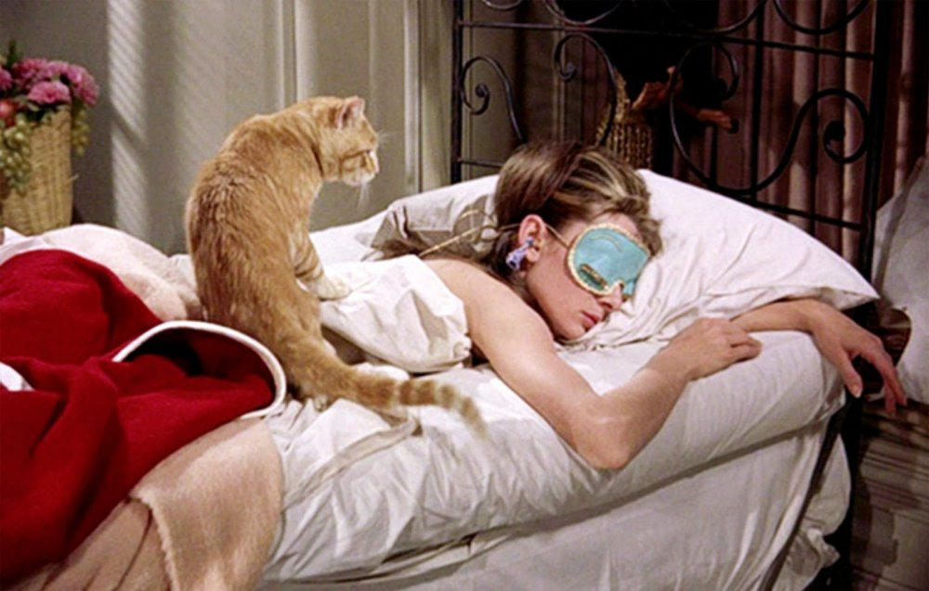

#### REVELANT POLICIES AND PROTOCOLS

### NON-SMOKING POLICY

On November 7, 2006, Ohio voters enacted a law to ban smoking in public places by approving the Smoke Free Workplace Act. As a result, Cat Welfare has adopted the following non- smoking restrictions:

* + Smoking is not permitted in any enclosed area of the facilities, including the main building and the storage shed.
  + Smoking is not allowed in any area of ingress or egress to any Cat Welfare facility.



### ANTI-HARASSMENT POLICY

Cat Welfare prohibits the harassment of any individual on the basis of race, color, religion, sex, age, national origin, ancestry, disability, military status, genetic information, sexual orientation or any other characteristic protected by applicable law. Cat Welfare does not tolerate any action by any person – Board of Directors, president, executive director, operations manager, employee, volunteer, member, donor, etc. – which constitutes unlawful harassment.

Any individual, who believes s/he has been harassed, or has witnessed harassment of another person, should promptly report the facts of the incident or incidents and the names of the individuals involved to the volunteer coordinator, operations manager, executive director or the chair of Cat Welfare’s Human Resource and Policy Committee. Reports will be promptly investigated and appropriate corrective action taken, without retaliation. Confidentiality will be maintained to the extent practicable..3

### WORKPLACE VIOLENCE PREVENTION POLICY

Cat Welfare Association is committed to providing a workplace that is free from acts of violence or threats of violence. Compliance with this policy is everyone’s responsibility.

Volunteers are to report any incident involving a verbal or physical threat of violence immediately to the volunteer coordinator, shelter operations manager, executive director or to the chair of the Human Resources and Policy Committee. Please do not assume that any threat is not serious. Report all threats. An individual may report such incidents without fear of retaliation of any kind.

All reported threats or acts will be promptly and thoroughly investigated and appropriate action will be taken.

### CAT BITE PROTOCOL

CWA understands that any incident involving a cat bite or scratch is very serious. Cats have sharp teeth that can cause deep puncture wounds, and sharp claws that can leave punctures or tears in the skin. Bites on the head, face, neck and hands are at high risk of infection, some requiring IV antibiotics and possible hospitalization.

In the event of a cat bite, please advise a staff member of the occurrence. A shelter supervisor will make sure the cat is quarantined (may or may not be caged) and will provide you with the cat’s vaccination records. You are strongly encouraged to seek immediate medical treatment from Urgent Care or the nearest hospital’s emergency room. The medical treatment at Urgent Care or the emergency room is paid for by Cat Welfare.

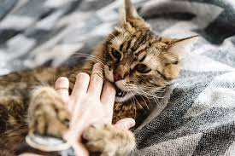

### VOLUNTEER CONDUCT

As a valued member of the Cat Welfare team, we ask you support the volunteer program by:

* Maintaining high standards of conduct
* Accepting the guidance and decision of the volunteer coordinator
* Being willing to learn and participate in orientation, training programs and meetings as appropriate
* Understanding the functions and maintaining a smooth working relationship with staff
* Staying within the boundaries of volunteer responsibilities

### ABSENTEEISM AND PUNCTUALITY

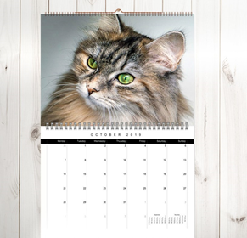It is essential that volunteers be on time and arrive when expected. If you are unable to arrive at your regular time, please let us know as soon as possible.

If you can’t fill your volunteer position as scheduled, please contact our volunteer coordinator 24 hours in advance. If suddenly ill, please inform her as soon as you are aware of your condition.

### RESIGNATION

If you plan to discontinue your volunteer status, we would like the chance to talk with you before your departure. Please give a minimum of two weeks’ notice to our volunteer coordinator.

We want to be sure to schedule time to thank you for your support and express our appreciation. In addition, with your permission, an exit interview will be conducted. Included in the interview will be questions about your reasons for leaving Cat Welfare, suggestions you may have for improving our organization and possibilities for your future involvement.

### TERMINATION

Volunteers who do not adhere to the rules and regulations, policies and procedures of Cat Welfare Association (CWA) are subject to dismissal. No volunteer will be dismissed without fair warning, or the opportunity to discuss the reasons for potential dismissal with supervisory staff. Possible grounds for dismissal may include, but are not limited to:

* + Abuse or mistreatment of feline residents, guests or staff
  + Gross misconduct or insubordination
  + Being under the influence of alcohol or drugs
  + Failure to abide by CWA policies and procedures

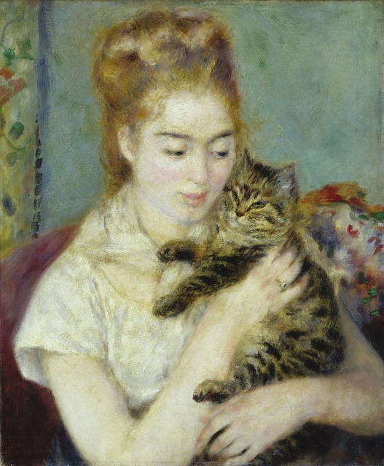

#### VOLUNTEER WAIVER AND AGREEMENT

## Volunteer Name: has read, understands and agrees to the following:

* I will treat all animals, people and property I come in contact with at The Cat Welfare Association, Inc. (CWA) with courtesy and respect at all times.
* While engaging in any CWA volunteer activity, I agree to be supervised and directed by the Volunteer Coordinator or other designated staff member.
* I will refrain from using language that others would consider profane or disrespectful.
* If I believe that a misunderstanding or communication problem exists between me and others (staff, volunteers, general public, etc.) I will report the situation to the Volunteer Coordinator or other appropriate shelter management.
* I may gain access to information that is private or personal regarding staff, members, volunteers, customers and/or the general public. I agree to maintain confidentiality and to refuse disclosure of such information.
* I give permission to use photographs or video footage of my volunteer activities.
* I will be on time for my scheduled shift or event.

* I will wear a volunteer name badge.
* I will dress appropriately, as guided by the shelter, for identification, safety, and because each volunteer is a representative of CWA in the eyes of the public. I understand offensive tee shirt slogans are prohibited. I may be asked to wear long pants, closed toe shoes, gloves, etc., depending on my volunteer activities. I will also exercise caution and take safety precautions with jewelry or body piercings when interacting with cats and kittens and engaging in volunteer activities.

## Volunteering at Cat Welfare is at will. A volunteer may be asked to leave the shelter or an event by shelter management. Active volunteer status may be terminated for any reason, with or without cause or notice, at any time by either parties-the volunteer or CWA.

## Volunteers are advised that the activity of performing volunteer work with the shelter animals may be hazardous, as it involves contact with animals that are unpredictable. As such, The Cat Welfare Association Inc. (CWA) cannot be held liable for injuries or accidents that may occur as a result of volunteer work with the animals. Volunteers understand that the following are some, but not all, of the risks:

* Bites or scratches from cats and kittens
* Slips/trips/falls resulting from wet floors/kennels or equipment
* Water or cleaners sprayed in eyes
* Injuries resulting from cage doors, equipment, etc.
* Flea/tick bites or ring worm infestation
* Internal or external parasites
* Zoonotic illnesses (human illness contracted from animals)
* Animal illness exposure to animals at home
* Injuries related to lifting animals, food, litter, or equipment
* Exposure to cleaners, latex gloves, bleach, parasite control products
* Exposure to or incidents relating to the public and/or volunteers(outbursts, inappropriate contact)
* Loss of personal property
* Any type of damage to car while parked on CWA grounds
* Damage to clothing from animals, cages, chemicals, etc.

Volunteers agree that The Cat Welfare Association and its Indemnitees (which are members, employees, officers, directors, agents, and representatives) shall not be held responsible or liable for any personal injury or other injury, including death; damage, loss, or expense to the volunteer or his/her property, whether or not such injury, death, damage, loss, or expense is caused by negligence of CWA, any Indemnitee, or a third party.

## Volunteers and their heirs, executors, and administrators agree to hold harmless each Indemnitee against any and all manner of legal actions, such as suits, debts, claims, or liability of any kind incurred while the Volunteer participates at the shelter and shelter event.

## Volunteers fully, completely, and unconditionally waive and release each Indemnitee from all rights, liabilities, duties, claims, charges, demands, actions, damages, costs, attorney fees, or expenses of any kind that Volunteers may have now or in the future against Cat Welfare or any Indemnitee relating to participation at the shelter.

Volunteers represent and warrant that s/he is physically and mentally fit to safely work with animals and public at the shelter. Should an accident or other medical emergency occur while participating at the shelter or while Volunteer is en route to or from The Cat Welfare Association sponsored events and CWA staff members are unable to timely reach Emergency Contacts for medical authorizations the Volunteer hereby gives consent for CWA staff members to authorize medical treatment.

If any provision of this Agreement is found to be unenforceable in any way, it shall be enforced to the maximum extent possible and all other provisions of this Agreement shall remain in full force and effect.

|  |  |
| --- | --- |
| Signature: | Printed Name: |
| Street Address: | City: |
| Zip Code: | Preferred Pronouns: |
| Employer: | Best Phone: |
| CLEARLY Printed Email: | Today’s Date: |
| Emergency  Contact Name: | Emergency  Contact Phone: |
| If Under 18, Birth Month and Year: | If Under 18, Parent/Guardian Signature: |

**How would you like to help CWA?**

|  |  |
| --- | --- |
| * Socialization | * The Catique Resale Shop |
| * Foster Care | * Offsite Events |
| * Cage/Shelter Cleaning | * Yardwork |
| * Administrative Help/Data Entry | * Other Idea? |
|  |  |

***For Office Use Only***

# Volunteer’s Identification Validated: